How to download apk on android FIRST TIME

1. **Allow unknown source**
2. You have to enable the installation from unknown sources on your device. To make it possible, perform the following steps:

* 1. Go to Settings > Apps > Special app access > Install unknown apps.

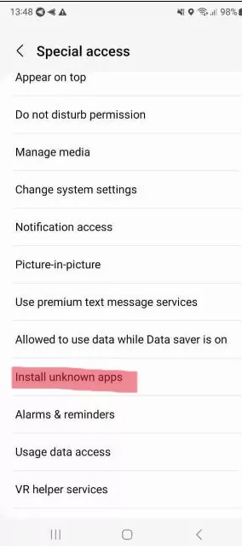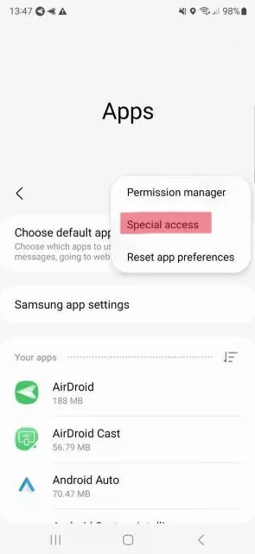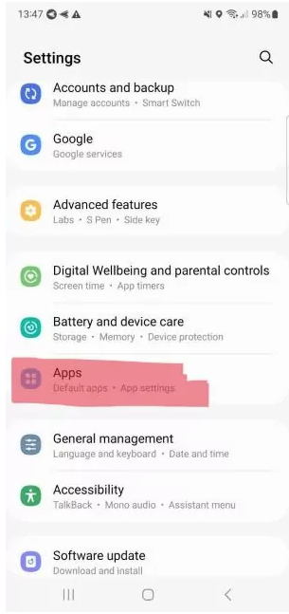

* 1. Locate the APK file on your device. The downloaded APKs can be found in the Downloads app. Or you can use a file manager to navigate to the Downloads folder.
* 2. Tap on the file name to start the installation. If this is the first time you're installing an APK from that file manager, the Downloads app, or the web browser, Android will throw a warning and ask your permission to continue. Give the permission and, depending on the app from where you're installing the APK, you may have to tap back to get to the installer. In some apps, you'll automatically be sent back to the installer.
* 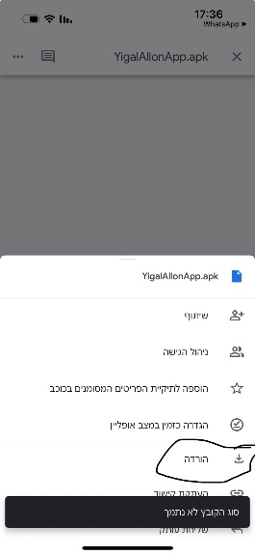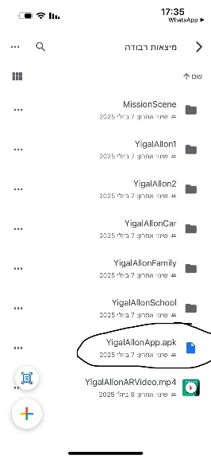3. Tap on Install, and the application will be installed successfully unless there